Meckel's Diverticulum
Meckel's diverticulum results from persistence of the proximal (ileal) end of the vitelline duct - specifically the base of the vitelline stalk where it attaches to the ileum.

Spectrum of Vitelline Duct Remnants
Depending on which portion of the duct fails to obliterate, different anomalies result:
Remnant | Structure | Clinical Presentation
Ileal end only (most common) | Meckel's diverticulum | Painless rectal bleeding, obstruction, inflammation
Entire abdominal portion | Omphaloileal (ileo-umbilical) fistula | Fecal discharge from umbilicus
Duct patent only at umbilical end | Umbilical sinus | Persistent umbilical discharge
Distal undegenerated end | Umbilical polyp | Bright red mucosal polyp at umbilicus
Midportion only survives | Vitelline / enterocystoma cyst | Intra-abdominal cyst between umbilicus and ileum
Fibrous cord (obliterated duct) | Fibrous band | Bowel obstruction by volvulus or internal hernia

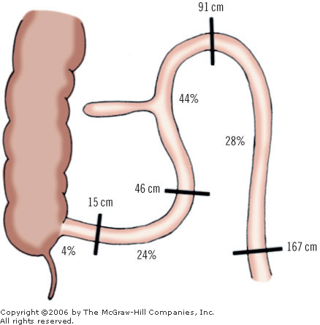

Rule of 2s and Its Limitations
Rule | Value
Prevalence | ~2% of the population
Distance from ileocaecal valve | ~2 feet (60 cm)
Length | ~2 inches (5 cm)
Male:female symptomatic ratio | ~2:1
Age of presentation | Within first 2 years (symptomatic cases)
Types of ectopic tissue | 2 main types — gastric (most common), pancreatic
Limitations of the Rule of 2s:
- Distance from ICV is highly variable — ranges from 10 cm to 100 cm in studies; the "2 feet" is a teaching approximation
- Only ~4% of Meckel's diverticula ever become symptomatic — the majority are silent incidental findings
Ectopic Tissues
- Gastric mucosa (~60% of ectopic tissue cases) — most clinically significant
- Pancreatic tissue (~15%)
- Duodenal mucosa, colonic mucosa, hepatobiliary tissue — rare
- Occasionally a combination of tissues

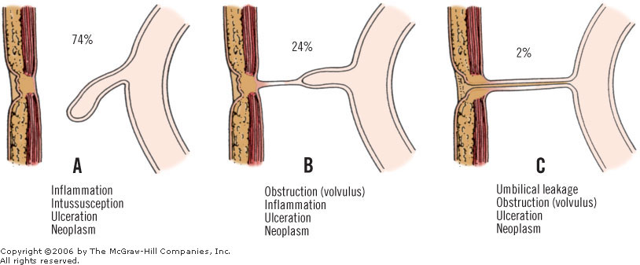
[WARNING]Why ectopic tissue? The vitelline duct endoderm retains pluripotent endodermal character
Clinical Correlations
Haemorrhage (most common complication in children)
- Ectopic gastric mucosa secretes HCl → peptic ulceration of adjacent ileal mucosa → painless rectal bleeding
Inflammation (Meckel's Diverticulitis)
- Clinically indistinguishable from acute appendicitis — right iliac fossa pain, fever, raised WCC
- Can perforate → peritonitis
- Rule: if appendix is normal at surgery for suspected appendicitis, always check for Meckel's diverticulum
Littre's Hernia
- Meckel's diverticulum found within an inguinal, femoral, or umbilical hernia sac
Incidental Meckel's — to remove or not?
- Current consensus: prophylactic diverticulectomy is reasonable when found incidentally in young patients with high-risk features; individualized decision in older patients
Key Points to Remember
- True diverticulum — contains all layers of the intestinal wall (mucosa, submucosa, muscularis, serosa)
- Supplied by a branch of the SMA (a remnant of the right vitelline artery) — confirming midgut origin
- The mesodermal component governs regression — not an intrinsic property of the endoderm
- Ectopic gastric mucosa → acid → ulceration of adjacent ileal wall (not within the diverticulum itself)
- Meckel's scan detects gastric mucosa, not the diverticulum itself — negative scan does not exclude Meckel's
- Littre's hernia = Meckel's in a hernia sac — the only hernia named after the contents, not the anatomical site
- CDX2 failure / SOX2 persistence in the remnant most likely explains ectopic gastric differentiation

